Experiment Details

|  |  |
| --- | --- |
| Department Name | Electrical engineering |
| Class | TY BTech |
| Semester | V |
| Subject Name | Power Electronics |
| Experiment No. | 1 |
| Experiment Name | MOSFET Characteristics |

Version History

|  |  |  |  |  |
| --- | --- | --- | --- | --- |
| Sr. No. | Version Number | Created By | Approved By | Date |
| 1 | v1.0 | Yuvraj Bhalekar | Mrs. Sushmita Amit Sarkar | 09/10/2020 |
|  |  |  |  |  |

AIM:

To plot

1. the output characteristics and
2. the transfer characteristics of an n-channel and p-channel MOSFET

THEORY:

A power MOSFET is a voltage-controlled device and requires only a small input current. The switching speed is very high and the switching times are of the order of nanoseconds. Power MOSFETs find increasing applications in low-power high-frequency converters.

The two types of MOSFETs are (1) depletion MOSFETs and (2) enhancement MOSFETs. An n-channel depletion-type MOSFET is formed on a p-type silicon substrate as shown in Figure.1(a), with two heavily doped n+ silicon sections for low resistance connections. The gate is isolated from the channel by a thin oxide layer. The three terminals are called gate, drain, and source. The substrate is normally connected to the source. The gate-to-source voltage VGScould be either positive or negative. If VGSis negative, some of the electrons in the n-channel area are repelled and a depletion region i created below the oxide layer, resulting in a narrower effective channel and a high resistance from the drain to source RDS. If VGSis made negative enough, the channel becomes completely depleted, offering a high value of RDS, and no current flows from the drain to source, IDS= 0. The value of VGSwhen this happens is called pinch off voltage VP. On the other hand, if VGSis made positive, the channel becomes wider, and IDSincreases due to reduction in RDS. With a p-channel depletion-type MOSFET,the polarities of VDS, IDS, and VGSare reversed, as shown in Figure 1(b).

An n-channel enhancement-type MOSFET has no physical channel, as shown in Figure 2(a). If VGSis positive, an induced voltage attracts the electrons from the p-substrate and accumulates them at the surface beneath the oxide layer. If VGSis greater than or equal to a value known as threshold voltage VT, a sufficient number of electrons are accumulated to form a virtual n-channel, as shown by shaded lines in Figure 2(a), and the current flows from the drain to source. The polarities of VDS, IDS, and VGSare reversed for a p-channel enhancement-type MOSFET, as shown in Figure 2(b).

(a) n-Channel depletion-type MOSFET

(b) p-Channel depletion-type MOSFET

|  |  |  |  |  |
| --- | --- | --- | --- | --- |
| (a) n-Channel depletion-type MOSFET | | (b) p-Channel depletion-type MOSFET | | |
| Figure 1. Depletion-type MOSFETs | | | | |
|  | |  |
| Figure 2. n-Channel and p-Channel symbol | | |

When the gate has a sufficiently positive voltage with respect to the source, the effect of its electric field pulls electrons from the n+ layer into the p layer. This opens a channel closest to the gate, which in turn allows the current to flow from the drain to the source. There is a silicon oxide (SiO2) dielectric layer between the gate metal and the n+ and p junction. MOSFET is heavily doped on the drain side to create an n+ buffer below the n-drift layer. This buffer prevents the depletion layer from reaching the metal, evens out the voltage stress across the n layer, and also reduces the forward voltage drop during conduction. The buffer layer also makes it an asymmetric device with rather low reverse voltage capability. MOSFETs require low gate energy, and have a very fast switching speed and low switching losses. The input resistance is very high, 109 to 1011 Ω. MOSFETs, however, suffer from the disadvantage of high forward on-state resistanceand hence high on-state losses.

(i) Transfer characteristics:

This characteristic shows the variation of drain current ID as a function of gate- source voltage VGS. Fig. 3. (a) shows typical transfer characteristics for n channel PMOSFET. Threshold voltage VGST is an important parameter of MOSFET. VGST is the minimum positive voltage between gate and source to induce n-channel. Thus, for threshold voltage below VGST device is in the off-state. Magnitude of VGST is of the order of 2 to 3 V.

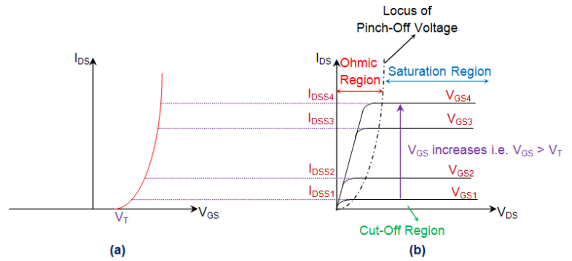

Figure 3. n-Channel enhancement-type MOSFET(a)Transfer characteristics (b)Output characteristics

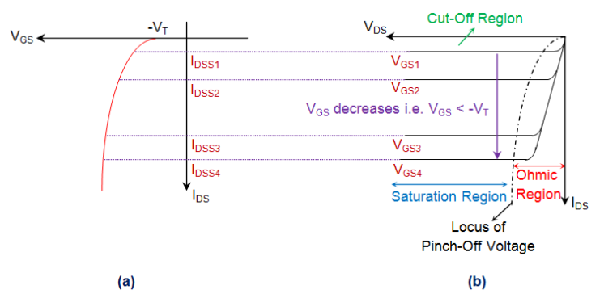

Figure 4. p-Channel enhancement-type MOSFET(a)Transfer characteristics (b)Output characteristics

(ii) Output Characteristics:

PMOSFET output characteristics, shown in Fig.3 (b), indicate the variation of drain current ID as a function of, Drain-source voltage VDS with gate-source voltage VGS as a parameter. For low values of VDS. The graph be Between ID-VDS is almost linear, this indicates a constant value of on-resistance RDS = V DS /ID For Given VGS ,if VDS is increased, output characteristic is relatively flat, indicating that drain current is nearly constant.

When power MOSFET is driven with large gate-source voltage, MOSFET is turned on, VDSON is small. Here, the MOSFET acting as a closed switch, is said to be driven into ohmic region (called saturation region in BJT). When device turns on, PMOSFET traverses ID - VDS characteristics from cut-off, to active region and then to the ohmic region, When PMOSFET turns off, it takes backward journey from ohmic region to cut-off state.

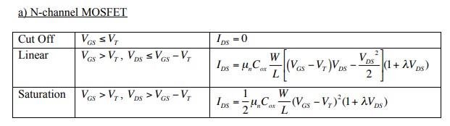

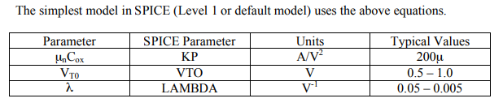

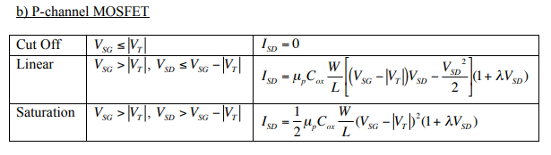

PRE-TEST:

1. What of the following is type of MOSFET?
   1. depletion mode
   2. enhancement mode
   3. **both a and b are correct**
2. why power MOSFET is called as voltage-controlled device?
   1. **voltage at the gate creates an electric field in the semiconductor channel that makes it conductive**
   2. voltage at the anode it conductive
   3. None of the above
3. Which of the following is region of operation in a MOSFET
   1. Ohmic/Triode region
   2. Saturation/Linear region
4. Pinch-off point
5. All of the above
6. Threshold voltage of MOSFET is …..
   1. 0V
   2. **0.45V**
   3. 0.7V
   4. None of the above

PROCEDURE:

OUTPUT CHARACTERISTICS:

1. Keep VGS constant at some value say 1.1 V by varying VGG (This value of VGG should be found and written of the simulation diagram)
2. Vary VDS in step of 1V up to 10 volts and measure the drain current ID.
3. Repeat the above procedure for VGS as 1.2V, 1.3V, 1.4V, 1.5V etc.

TRANSFER CHARACTERISTICS:

1. Set the voltage VDS constant at 10 V
2. Vary VGS by varying VGG in the step of 0.1 up to 1.55V and note down value of drain current ID. Tabulate all the readings
3. Plot the output characteristics VDS V/S ID and transfer characteristics VGS vs ID. (Developer should plot graph this step is carried on website with single click)

Observation tables:

OUTPUT CHARACTERISTICS

|  |  |  |  |  |  |  |  |  |
| --- | --- | --- | --- | --- | --- | --- | --- | --- |
| **Sr. No** | **VGS = 1.1(V)** | | **VGS = 1.2(V)** | | **VGS = 1.3(V)** | | **VGS = 1.4(V)** | |
| **VDS (mV)** | **ID­ (mA)** | **VDS (mV)** | **ID­ (mA)** | **VDS (mV)** | **ID­ (mA)** | **VDS (mV)** | **ID­ (mA)** |
| 1 |  |  |  |  |  |  |  |  |
| 2 |  |  |  |  |  |  |  |  |
| 3 |  |  |  |  |  |  |  |  |
| 4 |  |  |  |  |  |  |  |  |
| 5 |  |  |  |  |  |  |  |  |

|  |  |  |
| --- | --- | --- |
| Sr. No | V DS =10 (V) | |
| VGS (mV) | ID(mA) |
| 1 |  |  |
| 2 |  |  |
| 3 |  |  |
| 4 |  |  |
| 5 |  |  |

POST TEST:

1. A power MOSFET has three terminals called
   1. collector, emitter and base
   2. drain, source and base
   3. **drain, source and gate**
   4. *collector*, emitter and gate
2. As compared to power MOSFET, a BJT has…
3. **lower switching losses but higher conduction loss**
4. higher switching losses and higher conduction loss
5. higher switching losses but lower conduction loss
6. lower switching losses and lower conduction loss
7. Choose the correct statement among th following:
8. **MOSFET has positive** **temperature coefficient (TC) where as BJT has negative TC**
9. Both MOSFET and BJT have positive temperature coefficient (TC)
10. Both MOSFET and BJT have negative temperature coefficient (TC)
11. MOSFET has negative TC where as BJT has positive temperature coefficient (TC)
12. Choose the correct statement:
    1. Both MOSFET and BJT are voltage-controlled devices (CDs)
    2. Both MOSFET and BJT are current CDs
    3. **MOSFET is a voltage CD whereas BJT is a current CD**
    4. MOSFET is a current CD whereas BJT is a voltage CD

REFERENCES:

Write names of text books and reference books for experiment.